INTRODUCTION TO MODELSIM AND GATE LEVEL
MODELING
LAB # 01


Spring 2025
CSE-308L
Digital System Design Lab

Submitted by: Naveed Ahmad
Registration No.: 22PWCSE2165
Class Section: B

Student Signature: ______________

Submitted to:
Engr. Shah Zada Fahim Jan
05 March 2025

Department of Computer Systems Engineering
University of Engineering and Technology, Peshawar

Introduction To Modalism and Gate Level Modeling
OBJECTIVES
- Introduction to MODELSIM
- Introduction to gate level modeling
Lab Tasks:
Task 1: Implement a buffer at the gate level
Code
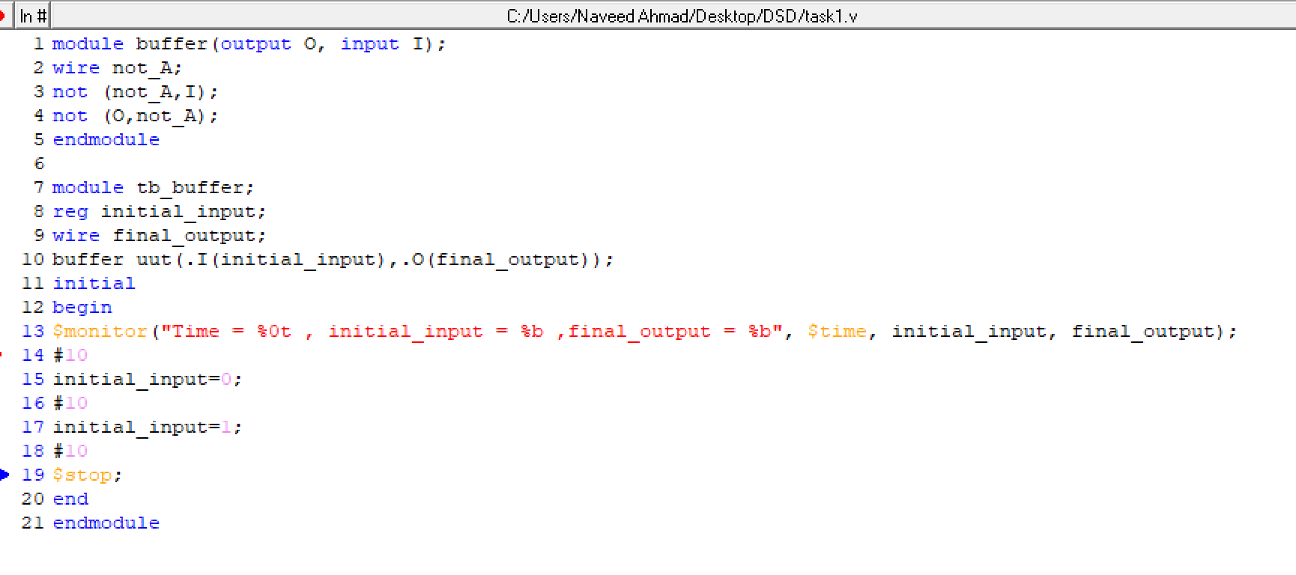
Output:
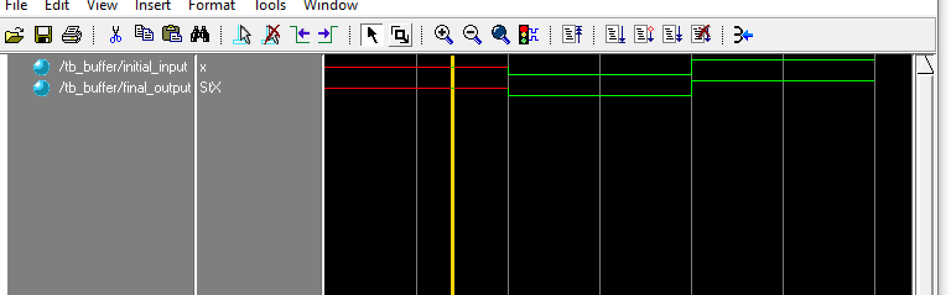

Task 2: Implement an inverter at the gate level.
Code
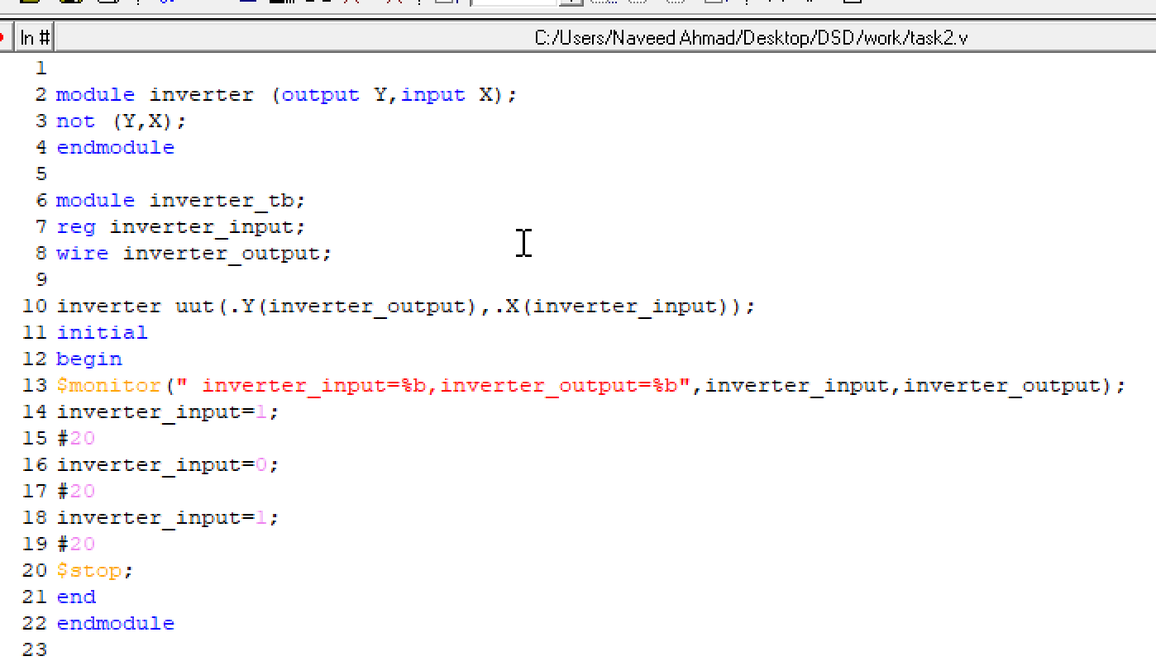
Output:

Task 3: Implement an OR gate using a NAND gates.
Code
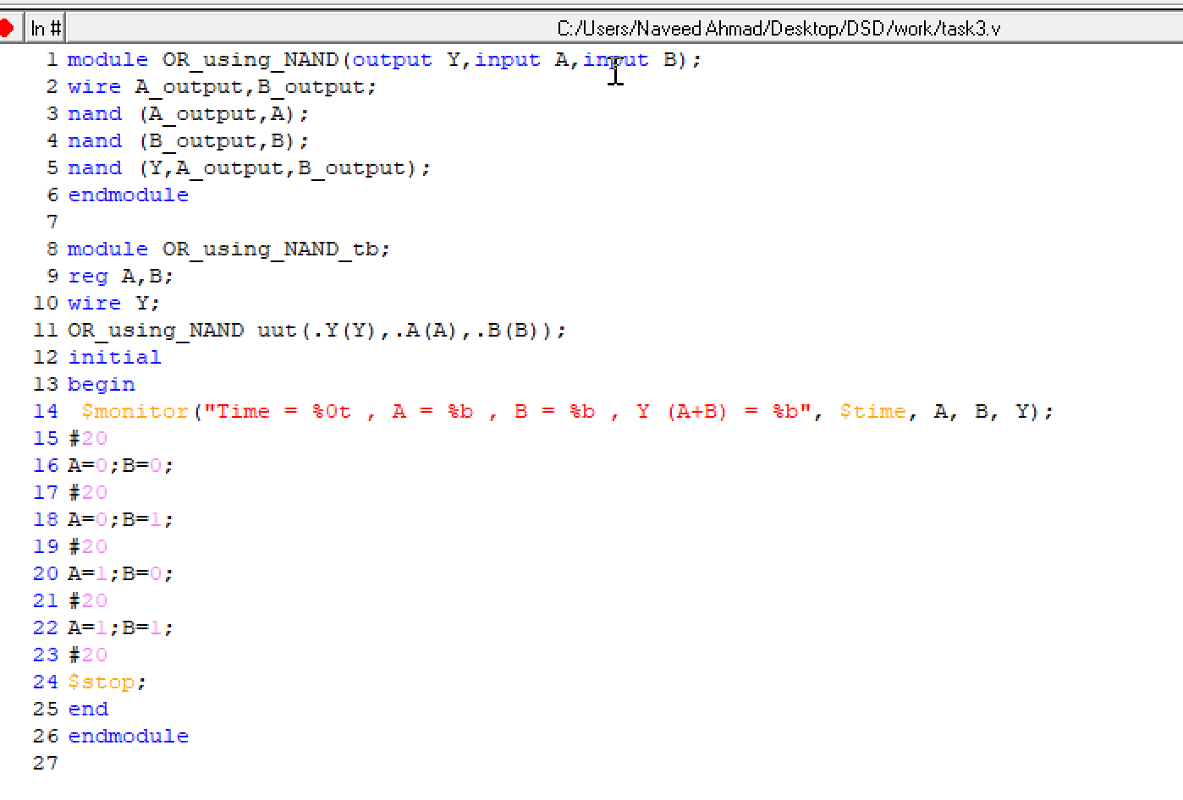
Output:
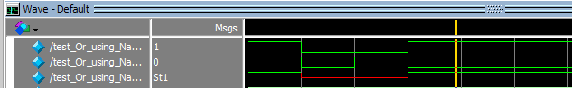

Task 4: Implement the following equation where z is output and x1, x2, x3, x4, and x5 are inputs of the circuit.
z = (y1 + y2)’
y1 = x1 . x2
Code:
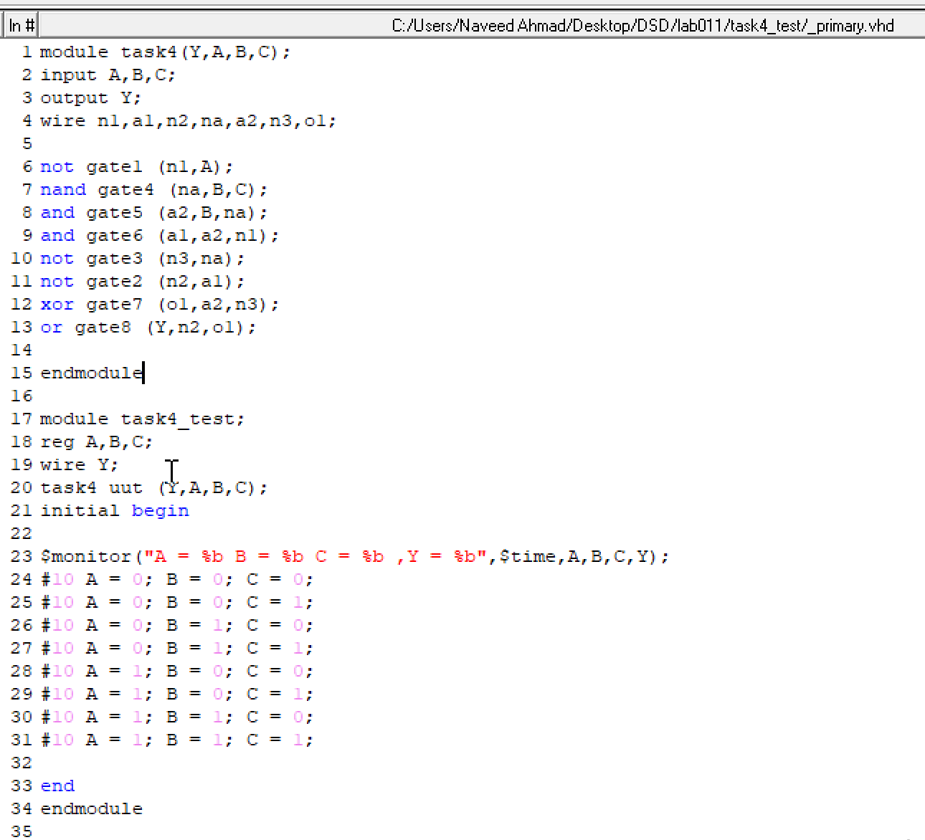
Truth table:
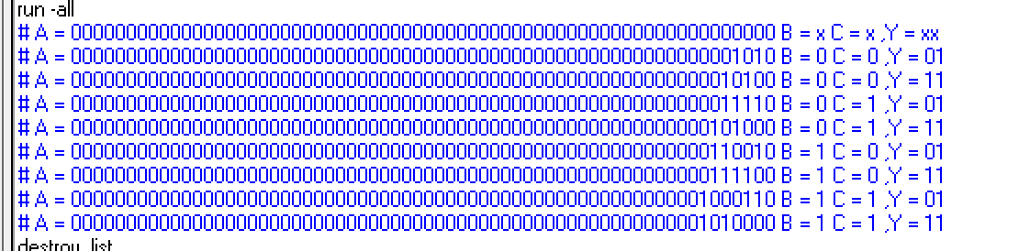

Data flow :
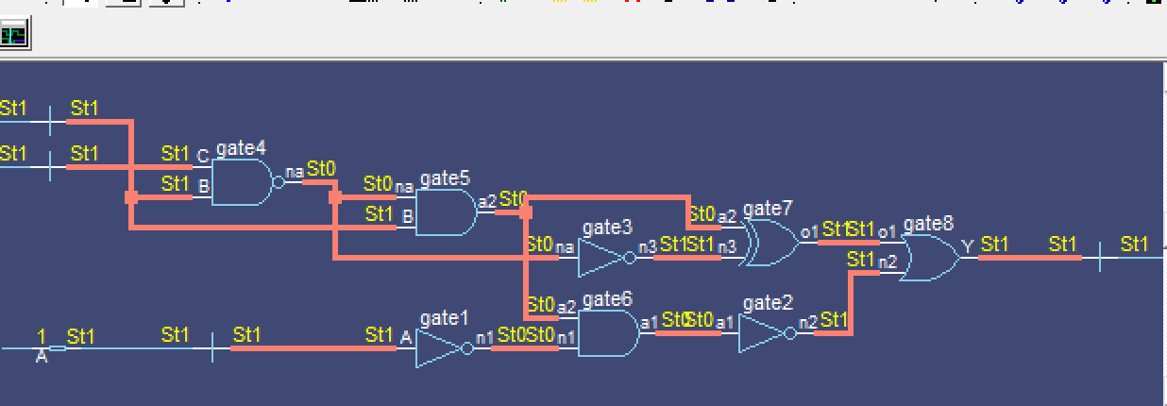

Output:
